|  |  |  |
| --- | --- | --- |
| |  |  | | --- | --- | | C:\Users\tmaddula\Desktop\untitled.png | C:\Users\tmaddula\Desktop\untitled.png | |

KT Document- RCIS

Design Document

Table of Contents

1. Introduction 5

2. Day 1 – KT Session 5

2.1 Overview of Crop Insurance and RCIS 5

2.2 Overview on Policies 5

2.3 Overview of CIMax application 6

2.3.1 Creating New policy in CIMax 6

2.3.2 Viewing Existing policy in CIMax 10

3. Day 2 – KT Session 11

3.1 CIMax Application Tabs and Fields: 11

3.1.1 Summary Tab 11

3.1.2 Entity Tab 11

12

3.1.3 AR Tab: 12

3.2 View the Policy in PDF and Printout 13

4. Day 3 – KT Session on Performance 15

4.1 Overview of Performance Testing Practice: 15

4.1.1 Application Access 15

4.1.2 Scripting 15

4.1.3 Reporting Structure & Performance Test Metrics 16

4.1.4 Site Scope 16

4.1.5 Merging Graphs 17

4.1.6 Brief explanation on Scripting 18

5. Day 3 – KT Session on Automation 18

5.1 Automation Framework Components 18

5.1.1 Unified Functional Testing tool 18

5.1.2 Application Lifecycle Management tool 18

5.1.3 Team Foundation Server tool 18

5.1.4 CIMax Regression Test Builder 18

6. Day 4 – KT Session on Performance 19

6.1 Performance center & HP ALM 19

6.2 Analysis Summary 20

6.3 SLA (Service Level Agreement) 21

6.4 SLA Status 22

6.5 Preparation of Excel Sheet 23

6.6 Report generated by Graph 23

7. Day 4 – KT Session on Automation 24

7.1 Regression Test Life Cycle 24

7.2 QC Path for Automation Suite in Test Plan 24

8. Glossary 25

**Revision History**

|  |  |  |  |  |
| --- | --- | --- | --- | --- |
| **Date** | **Version** | **Description** | **Author** | **Reviewer** |
| 05/07/2018 | 1.0 | Initial Draft | Trinadh, Ram, Keerthana & Viswa |  |
| 06/07/2018 | 1.1 | Initial Draft | Trinadh, Ram, Keerthana & Viswa |  |
| 09/07/2018 | 1.2 | Initial Draft | Trinadh, Ram, Keerthana & Viswa |  |
| 10/07/2018 | 1.3 | Initial Draft | Trinadh, Ram, Keerthana & Viswa |  |

# Introduction

This document briefs about the Day-wise Knowledge Transfer sessions given to the team. It covers the information about the RCIS, Overview of Crop Insurance, policies, CIMax application, new policy creation and setup in CIMax, Performance overview of CIMax application, Automation Framework overview and Automation setup.

# Day 1 – KT Session

## Overview of Crop Insurance and RCIS

Crop insurance consists of federal and private (non-federal) plans of insurance. Together they provide a risk-management tool available to agricultural producers. Congress first authorized federal crop insurance in the 1930s and created the Federal Crop Insurance Corporation (FCIC) in 1938 to carry out the program that continues today through the enactment of the Federal Crop Insurance Act. Tax dollars fund the federal crop insurance program.

RCIS is a leading provider of agricultural insurance in the United States.In addition to providing insurance on more than 130 different crops under a variety of plans, we deliver technology and services designed to aid our agents - together we help protect America’s farmers and ranchers.

Zurich American Insurance Co. acquired Rural Community Insurance Agency (RCIA) and its subsidiary Rural Community Insurance Co. (RCIC) from Wells Fargo Insurance for $700 million during 2016.

## Overview on Policies

* **Actual Production History (APH)**

In [United States federal agricultural law](https://en.wikipedia.org/wiki/Agricultural_policy_of_the_United_States), the terminology Actual Production History (APH) denotes a record of an agricultural producer’s [crop yields](https://en.wikipedia.org/wiki/Crop_yield) over a 10 years period. Such records are used by the [Federal Crop Insurance Corporation](https://en.wikipedia.org/wiki/Federal_Crop_Insurance_Corporation) to determine “normal” production levels for a producer. The term "Actual Production History insurance" is used synonymously with  [Crop Insurance](https://en.wikipedia.org/wiki/Multi-Peril_Crop_Insurance).

* **Acreage Report (AR)**

Farm Service Agency policy requires that producers participating in several programs submit an annual report regarding all cropland use on their farms. These programs include Agriculture Risk Coverage (ARC) and Price Loss Coverage (PLC). Reporting also applies to those who receive marketing assistance loans or loan deficiency payments. Failure to file an accurate and timely acreage report for all crops and land uses can result in loss of program benefits. Producers are required to self-report all cropland on each farm to FSA annually. FSA uses these data to determine payment eligibility (land must be in an eligible agricultural use to qualify for payments) and to calculate losses for various disaster programs.

* **Approved Insurance Provider (AIP)**

Approved insurance providers (AIP) are contracted with the FCIC and supervised by RMA to follow the established terms and conditions of the federal crop insurance program. There are currently 16 AIPs contracted with the FCIC. Rural Community Insurance Company (RCIC) issues federal and private crop insurance policies to farmers and ranchers across the United States.

## Overview of CIMax application

CIMax application keeps track of all the crop insurance business and makes it extremely easy to calculate and track quotes, APH records, acreage reports, and notice of loss. Mapping services have also been updated with the addition of FarmMaps to the *CIMax* application.

### Creating New policy in CIMax

* Launch CIMax Application and create new policy by clicking on “New MPCI policy”

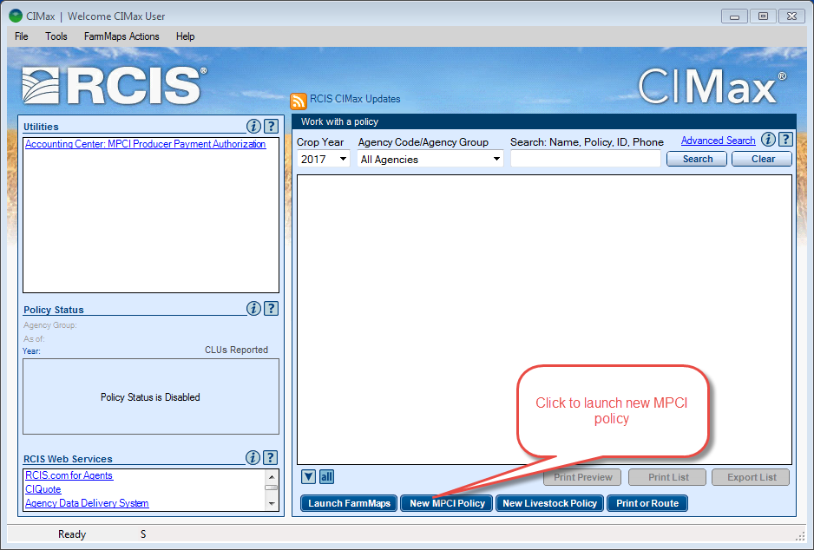

* Select Year as 2018 in Entity Tab and fill in all the rest of the fields in the entity tab

**Note:** When selecting the Agency, give the appropriate agency applicable to the selected State.

Example, look at the number associated to state and enter the same number in Agency field which will list the associated agency list. Here IL state has 12. So enter 12 in the agency which will lists the agency starts with 12

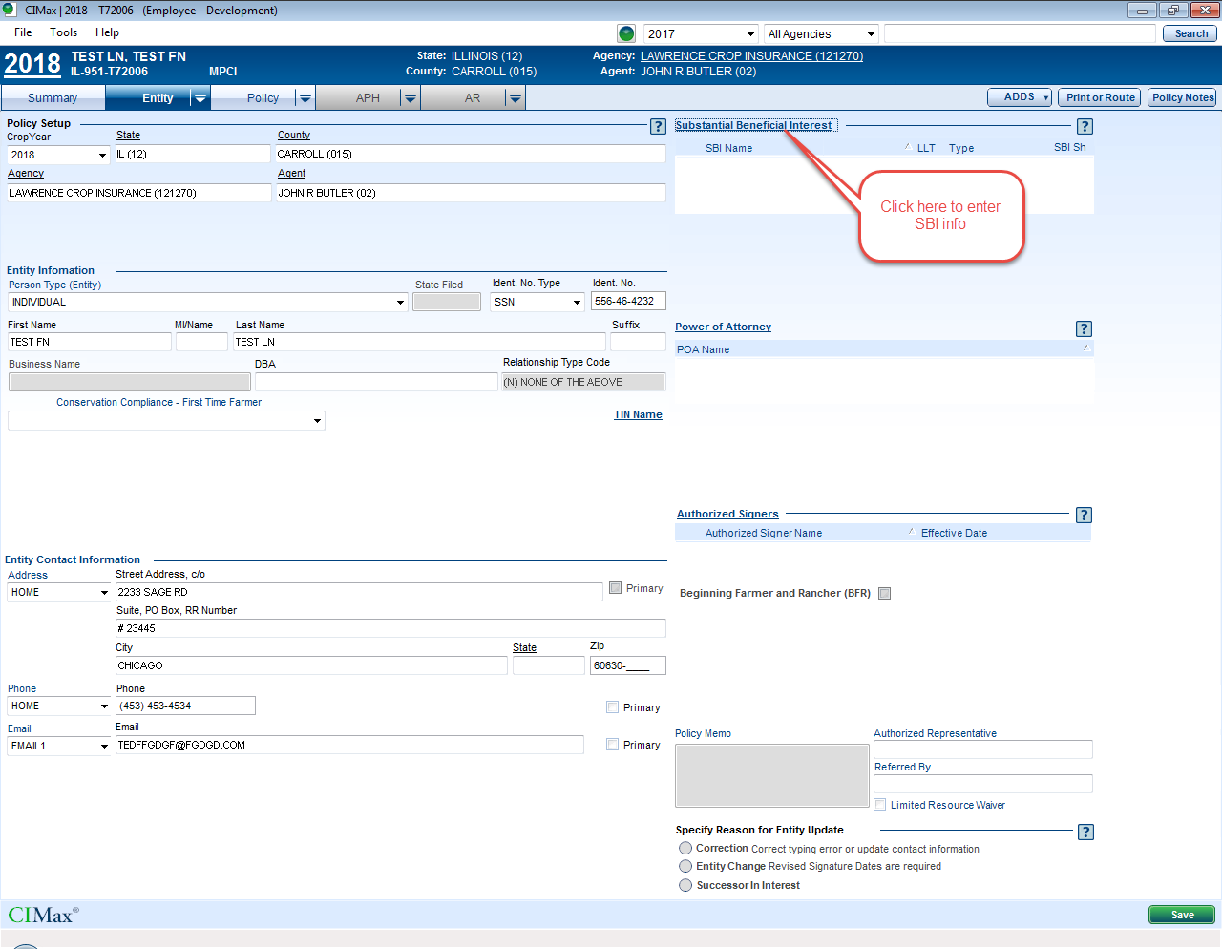

* Click on Substantial Benefical Interest (SBI) and fill in the details and click Ok

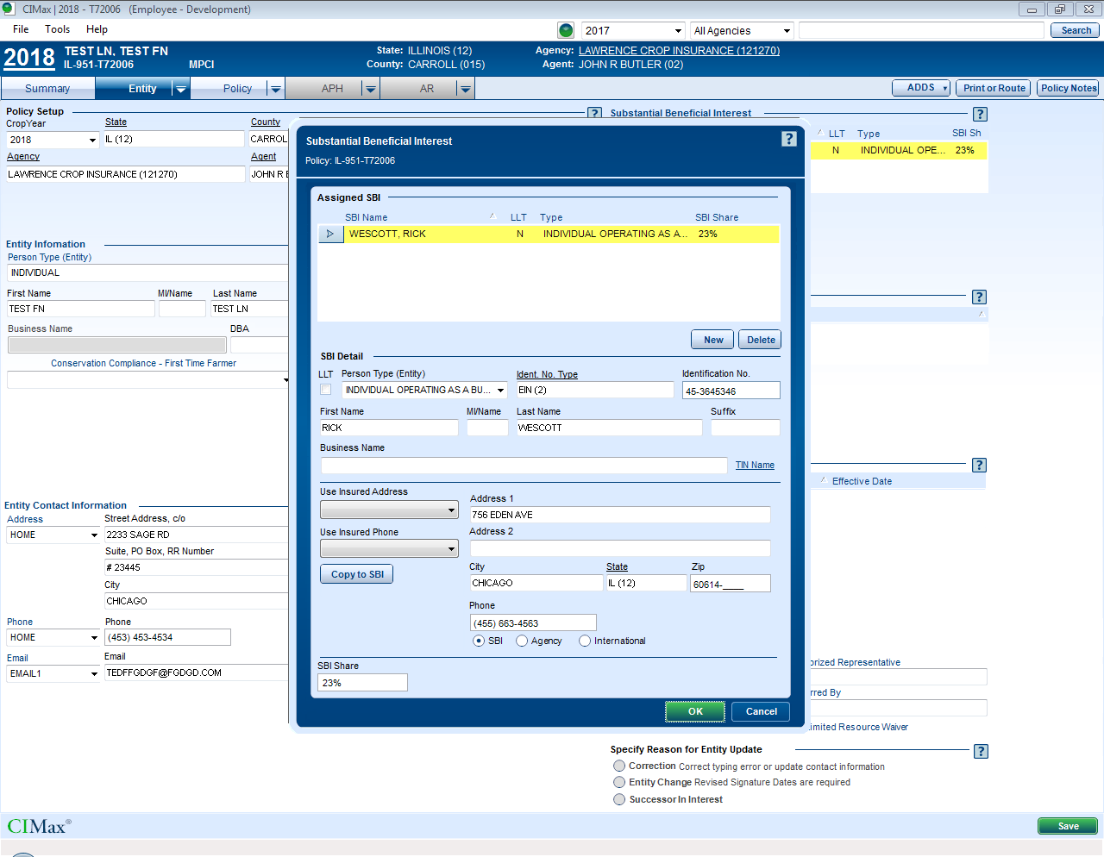

* Click on Policy Tab, Create 1 crop line for Corn as below and Click Save

Apply Signature Dates window will be displayed. Enter the data as in the screen shot and click Ok

Policy will be saved.

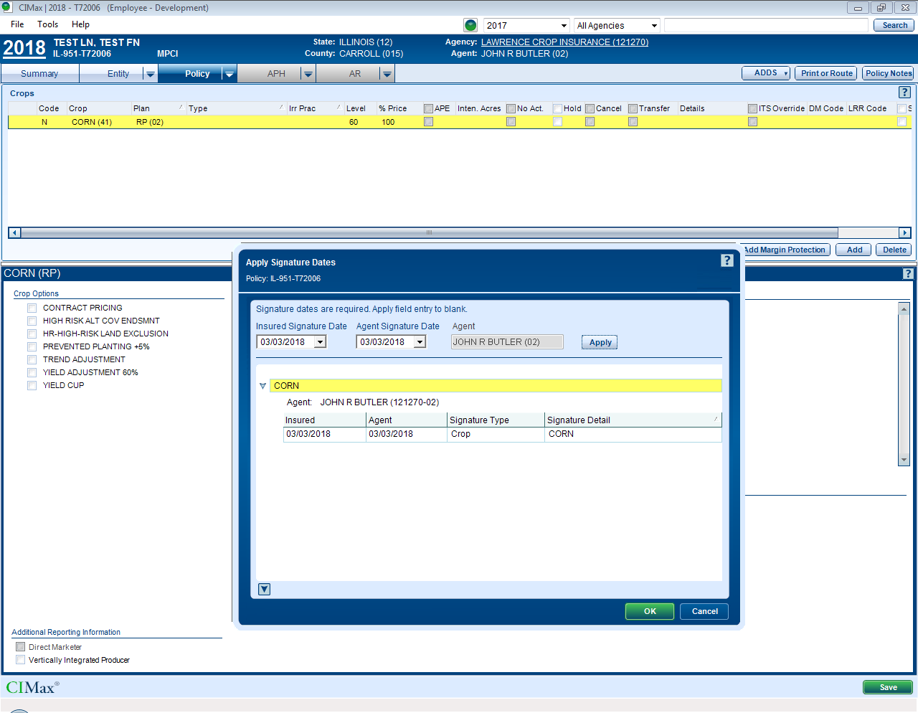

### Viewing Existing policy in CIMax

* View the existing policy created in above steps as shown in the screenshot below.

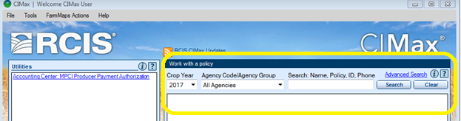

# Day 2 – KT Session

## CIMax Application Tabs and Fields:

### Summary Tab

Summary tab contains information related to policy, signature dates, Billing details and Producer summary reports.

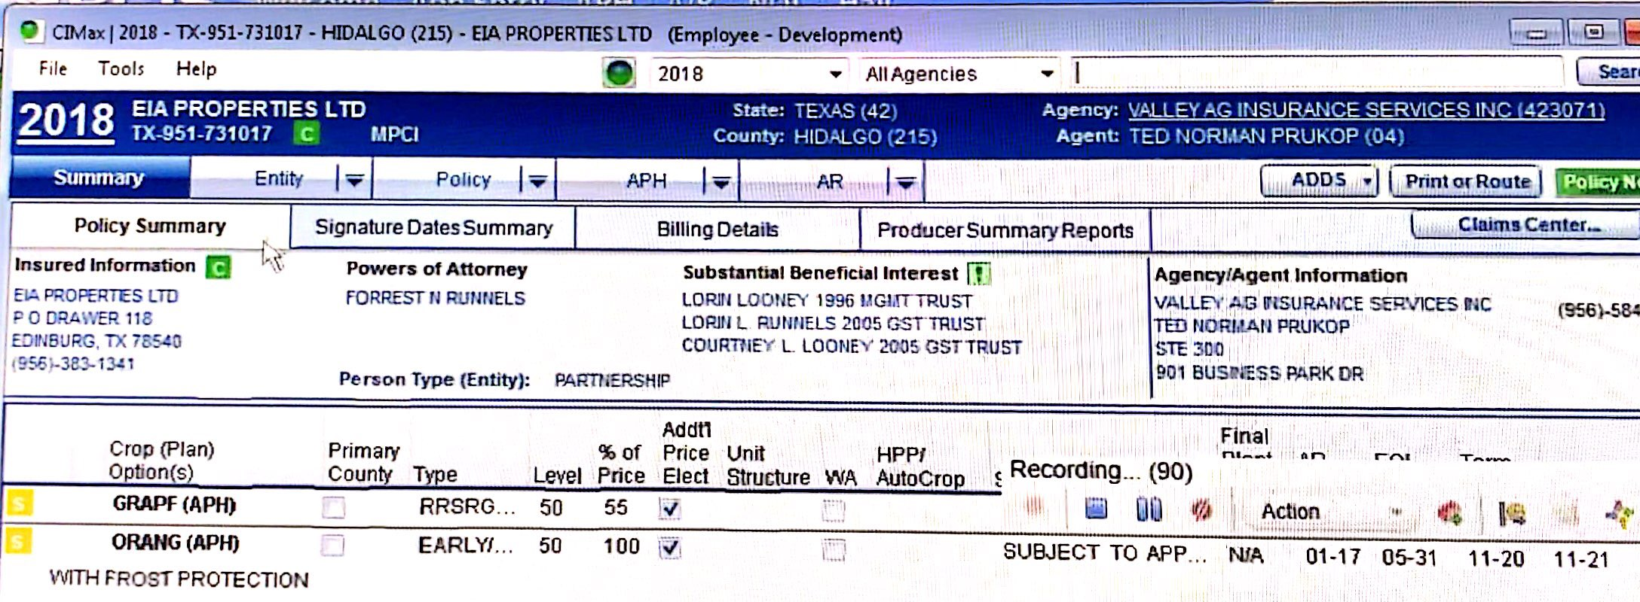

### Entity Tab

Entity tab contains information related to Policy Setup, Substantial Beneficial Interest, Entity Information, Power of Attorney, Entity Contact Information and Authorized Signers.

Policy Setup contains below fields:

* Crop Year
* State
* Country
* Agency/Agent

Entity Information contains below fields:

* Person type
* Identity/Identity number type
* First Name
* Last Name
* Business Name
* DBA
* Relationship Type code

Entity Contact Information contains below fields:

* Address
* Phone
* Email

### 

### AR Tab:

AR Tab contains information about Crop Information like Crop Levels, % Price, Plan and Crop Type etc as shown in the below screenshot.

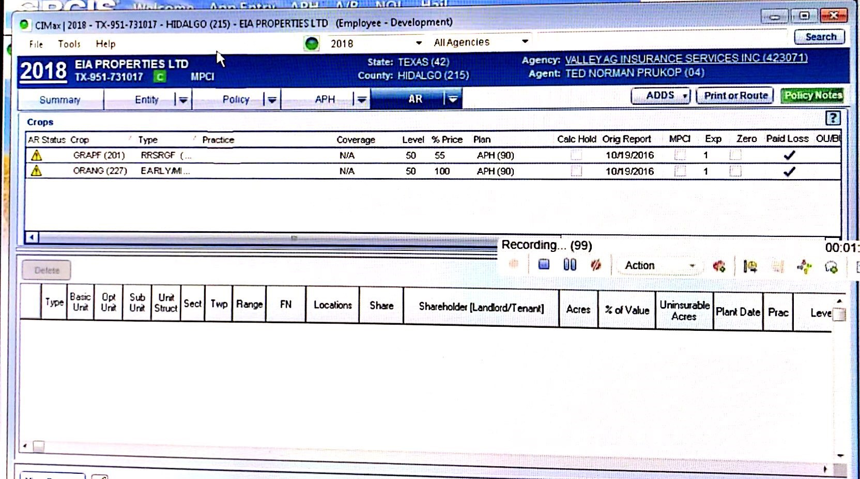

## View the Policy in PDF and Printout

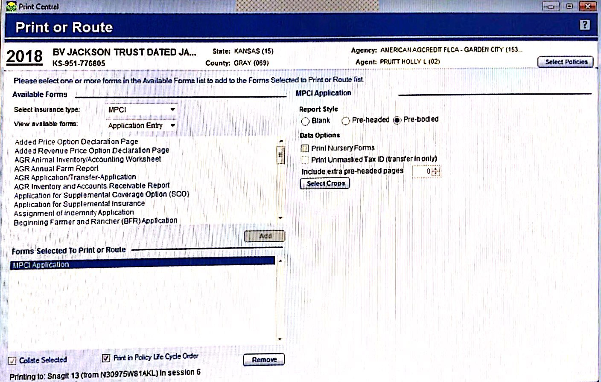

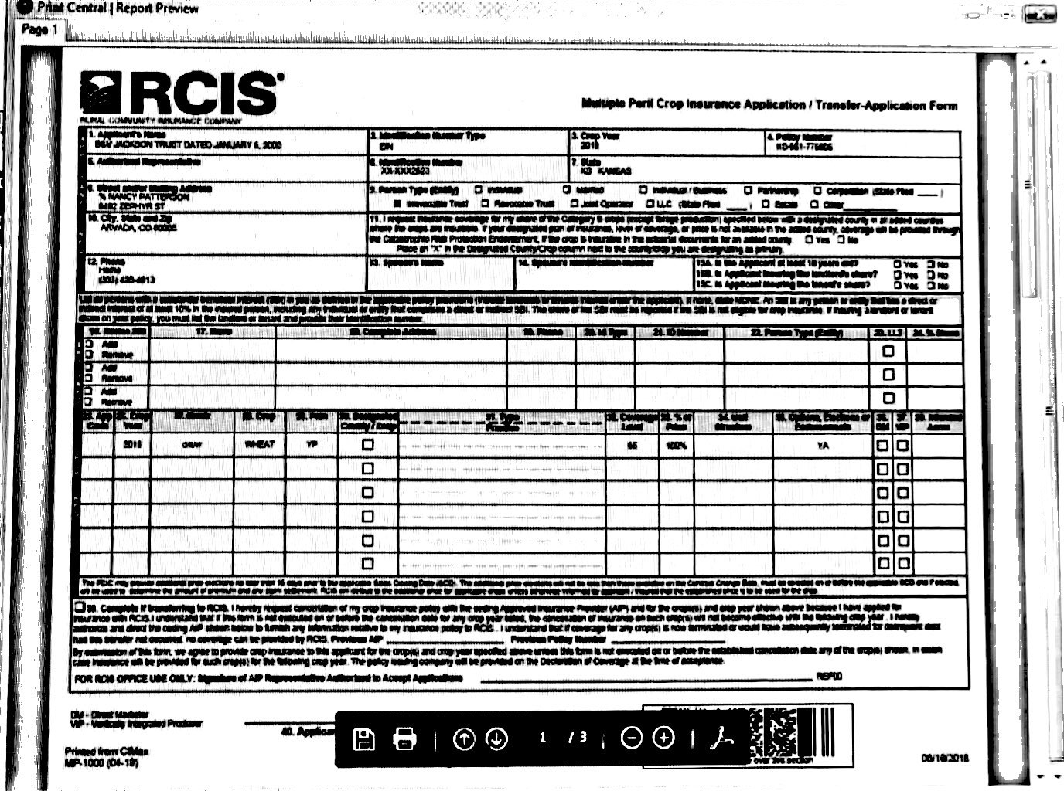

# Day 3 – KT Session on Performance

## Overview of Performance Testing Practice:

### Application Access

To Access the application we need to open Vugen and follow the below steps:

* Open Vugen tool
* Select the Protocol as “Citrix”
* Click on “ Record a New Script”
* Submit the RCIS application Credentials against the server.
* Start recording the RCIS application as per the business flow.

### Scripting

Login in to the application manually and access the application and record the script as per business flow as below:

* Login
* Search Policy by Name/ID/Phone number
* Search Policy by Agent Group/Agent name

* Logout the RCIS Application.

### Reporting Structure & Performance Test Metrics

It briefs about the different types of reports generated from the different test cases and capture the Total response time of the application.

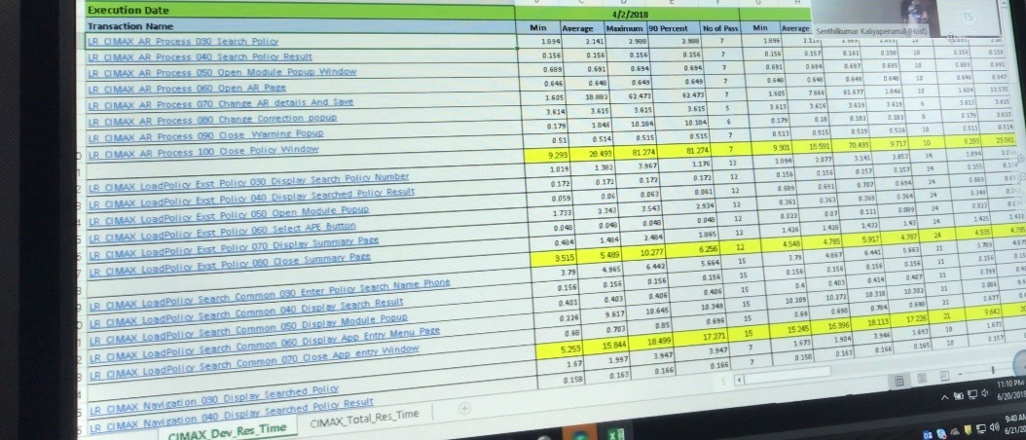

### Site Scope

Using HP Sitescope monitoring tool, we can derive the different metrics like CPU, Memory and Disk Utilization of the application server and generating the reports.

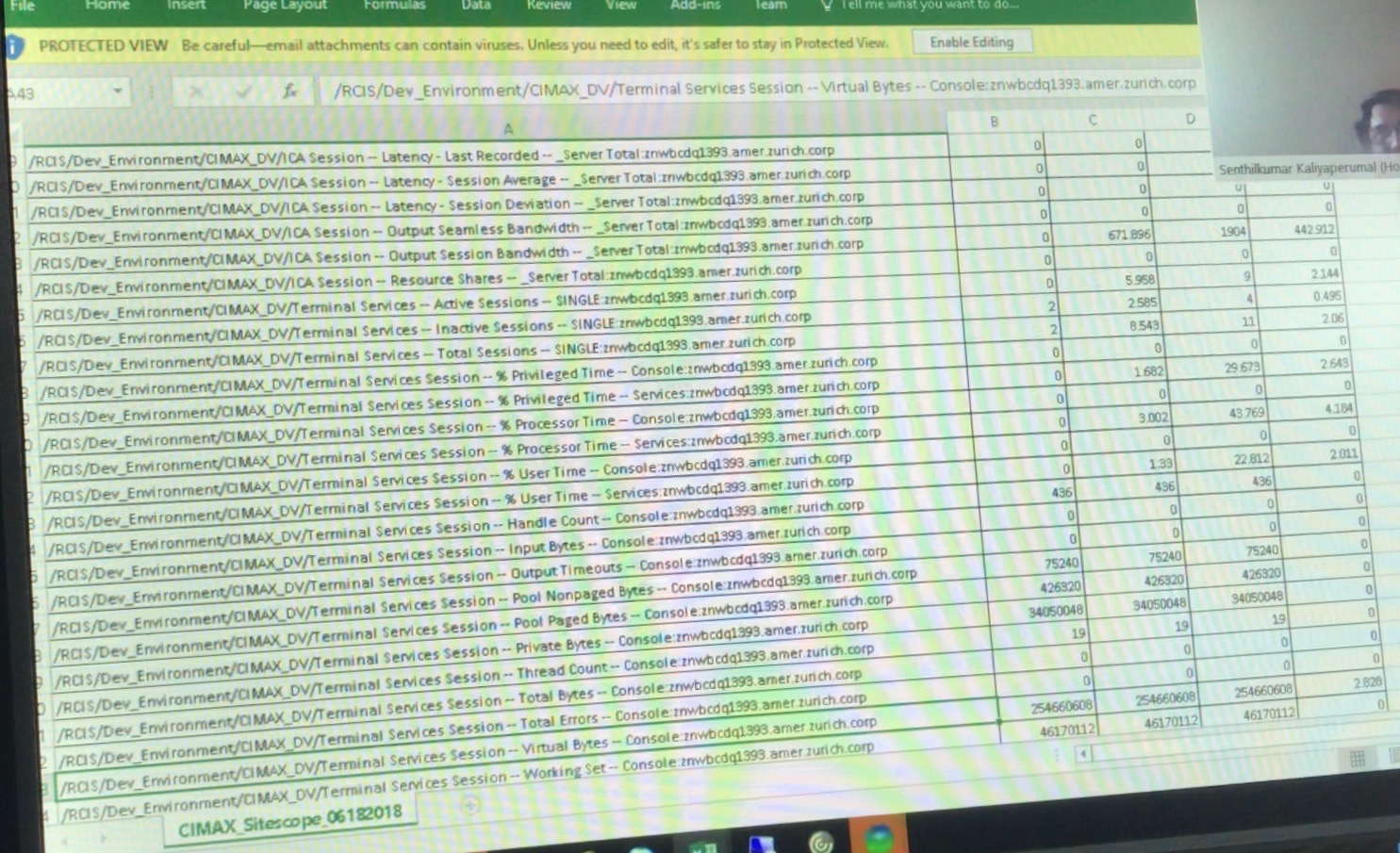

### Merging Graphs

After Execution of test we get multiple reports and graphs. For analyzing the performance we need to merge the Graphs shown below:

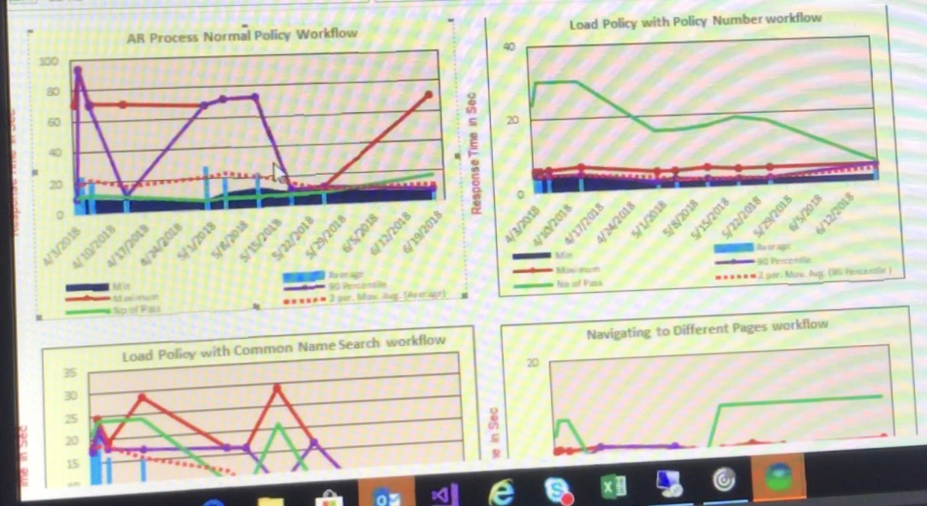

### Brief explanation on Scripting

As part of the scripting we used arrange the aspect ratio of the application and Vugen tools should be maintained same. We need to enhance the script by using different C-techniquies, Parameterization, Correlation and Checkpoints.

The major Exception handling in the Citrix Environment is Co-ordination ‘X’ and ‘Y’. After recording is done in the Vugen, we should check the application manually whether the Co-ordination ‘X’ and ‘Y’ are same to the script.

# Day 3 – KT Session on Automation

## Automation Framework Components

The Framework is a Hybrid Framework which is combination of Data Driven and Keyword Driven framework. We use Shared Object Repository method to store object properties and is been imported to ALM for accessing from UFT Scripts. Also, we access test data from the Oracle Database.

Below are the tools used in this framework.

* UFT – Unified Functional Testing tool
* ALM – Application Lifecycle Management tool
* TFS – Team Foundation Server tool
* CIMax Regression Test Builder

### Unified Functional Testing tool

UFT is used for creating automation test scripts and test engine for executing the UFT tests.

ALM. HPE Unified Functional Testing software, formerly known as HP Quick Test Professional, provides [functional](https://en.wikipedia.org/wiki/Functional_testing) and [regression test](https://en.wikipedia.org/wiki/Regression_testing) automation for software applications and environments. HPE Unified Functional Testing can be used for enterprise quality assurance.

### Application Lifecycle Management tool

ALM is test and defect management tool used for creating test cases in Test Plan and execution of UFT tests and also creating defects for any bugs.

### Team Foundation Server tool

Team Foundation Server is a [Microsoft](https://en.wikipedia.org/wiki/Microsoft) product that provides [source code management](https://en.wikipedia.org/wiki/Revision_control) , reporting, [requirements management](https://en.wikipedia.org/wiki/Requirements_management), [project management](https://en.wikipedia.org/wiki/Project_management) , automated builds, lab management, [testing](https://en.wikipedia.org/wiki/Software_testing) and [release management](https://en.wikipedia.org/wiki/Release_management) capabilities.

### CIMax Regression Test Builder

CIMax Regression Builder is used to search the Test Case Id and to know the order of execution and Data used for the Test Case.

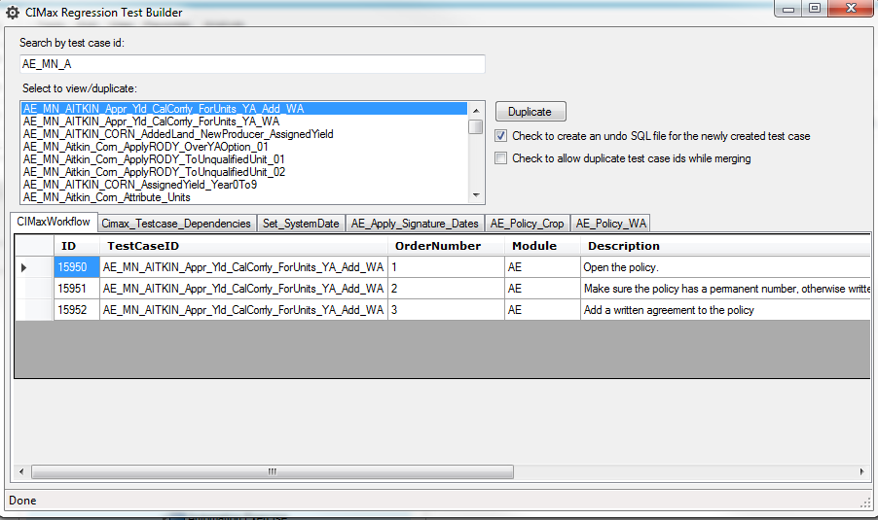

# Day 4 – KT Session on Performance

## Performance center & HP ALM

It is used to conduct different types of test in the Performance center below steps:

* Submit the Zurich HP ALM URL.
* Submit the login credentials.
* Select project as ‘RCIS’.
* Click on ‘Login’ Button.
* Page will be redirected to the HP performance center.
* Select “Test Management”
* Select “CIMAX”
* Upload a Vugen script.
* Design the scenario and conduct the test.
* Click on “Run & Analysis”.
* Save the Raw results in Zip file.

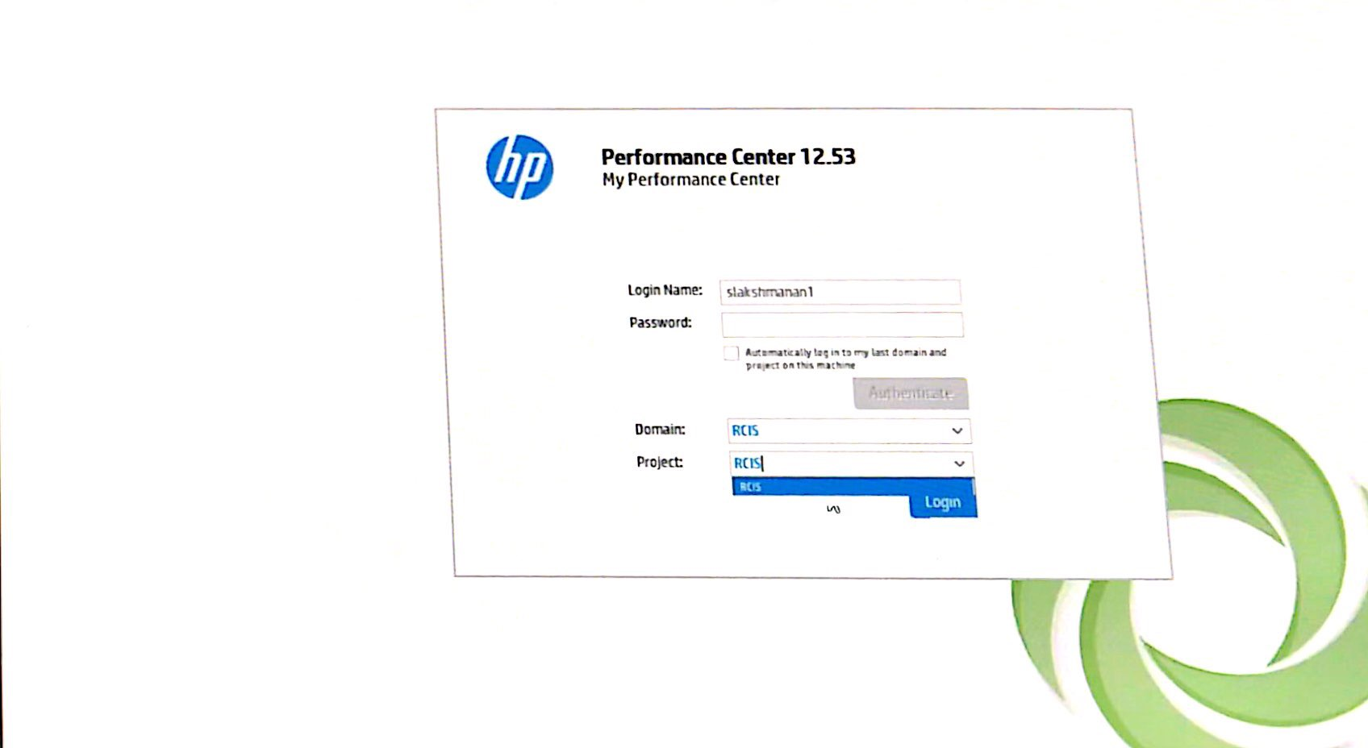

## Analysis Summary

Open the Loadrunner result file and it invoke the Analyzer tool to analysis the results of different graphs and metrics like

* Running Vuser
* Hit per sec
* Throughput per sec
* Transaction summary
* Average transaction response time

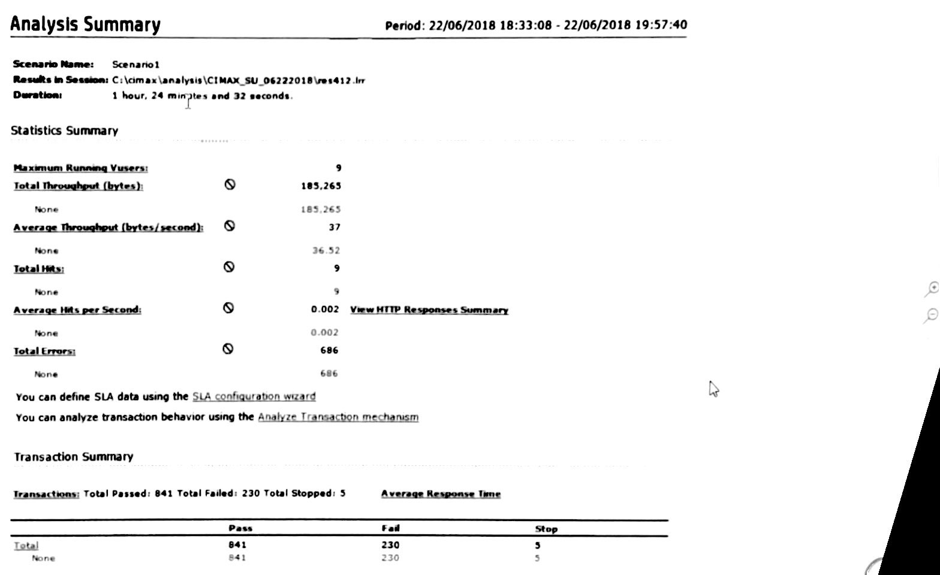

## SLA (Service Level Agreement)

Service Level Agreement contains below:

* Transaction Response Time as Percentile
* 90th percentile
* Threshold point

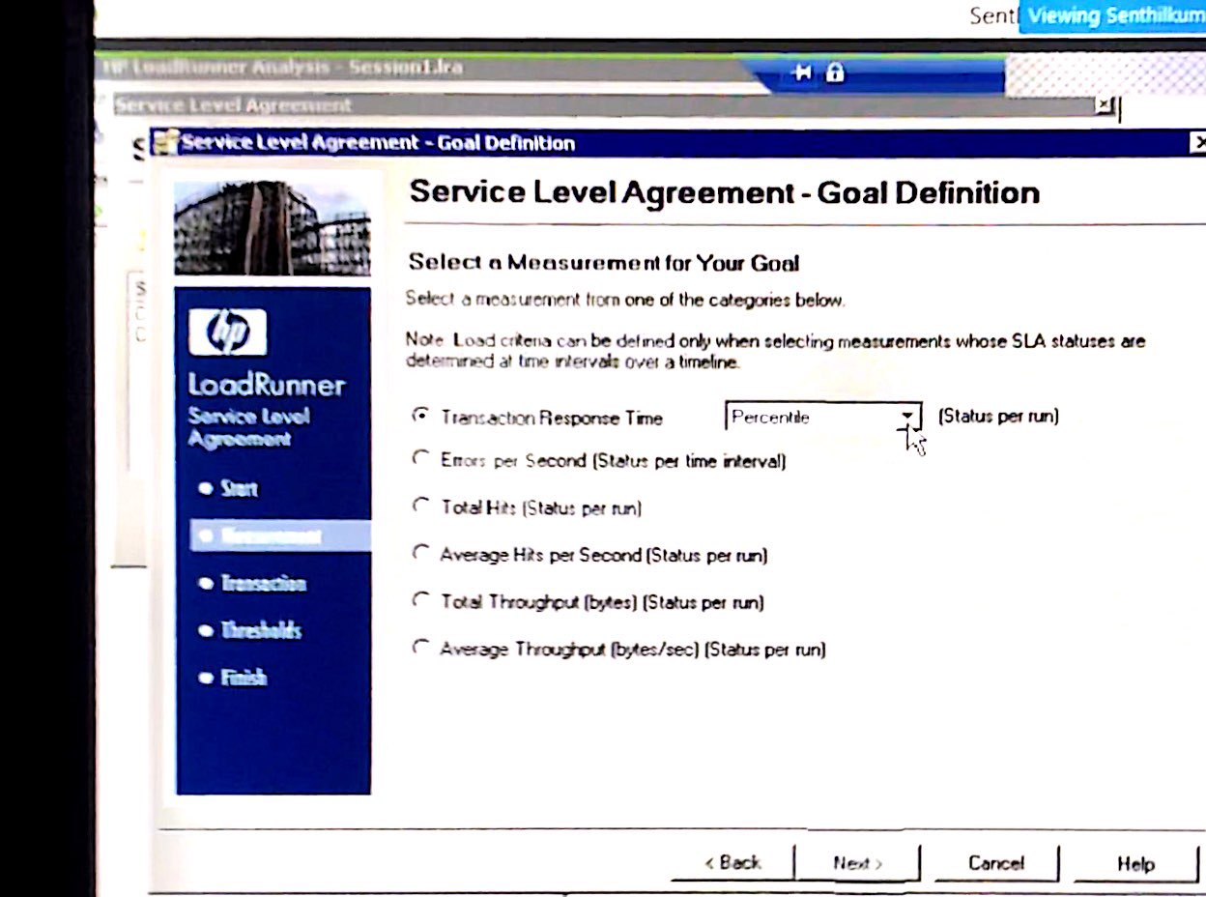

## SLA Status

Once we submit the SLA’s, it validate the results which are reached as per the SLA’s, it filters and display the transaction which are shown below:

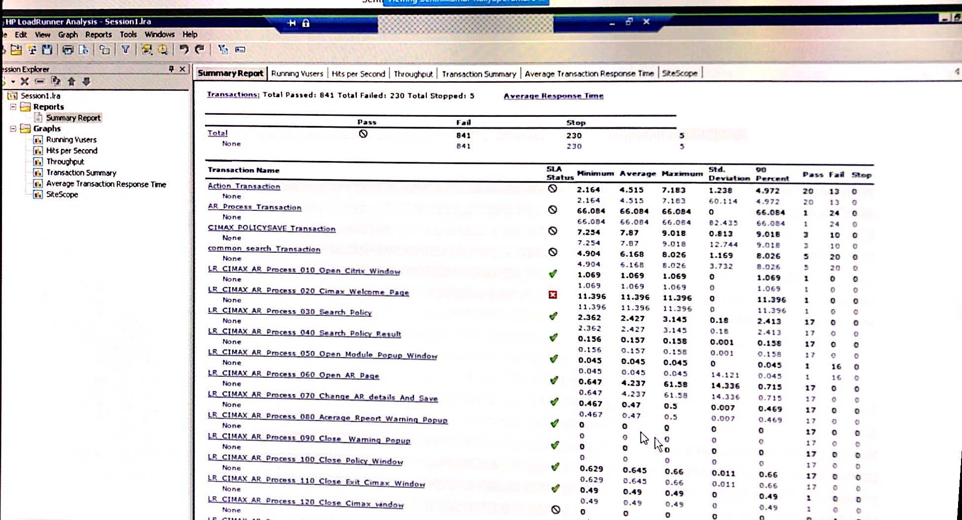

## Preparation of Excel Sheet

Copy the SLA results and paste it into Excel and filter the valid results as shown below:

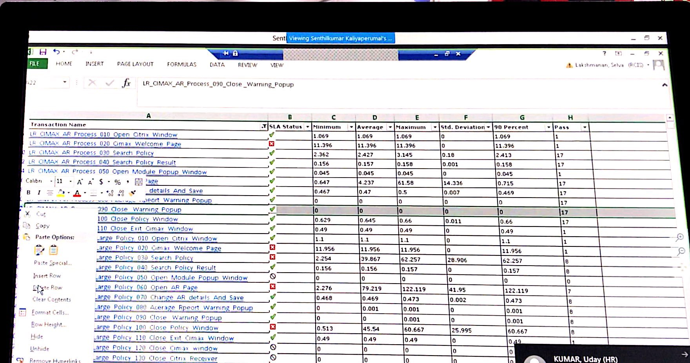

## Report generated by Graph

To generate the graph open the file with Analyzer and select the graphs mentioned below:

* Running Vuser
* Hit per sec
* Throughput per sec
* Transaction summary
* Average transaction response time
* Site scope
* First buffer hit ratio Break down

Copy First buffer hit ratio Break down, Running Vuser, Hit per sec, Throughput per sec, Transaction summary, Average transaction response time, Site scope graphs into Excel along with pervious SLA Results and prepare the Complete test Report.

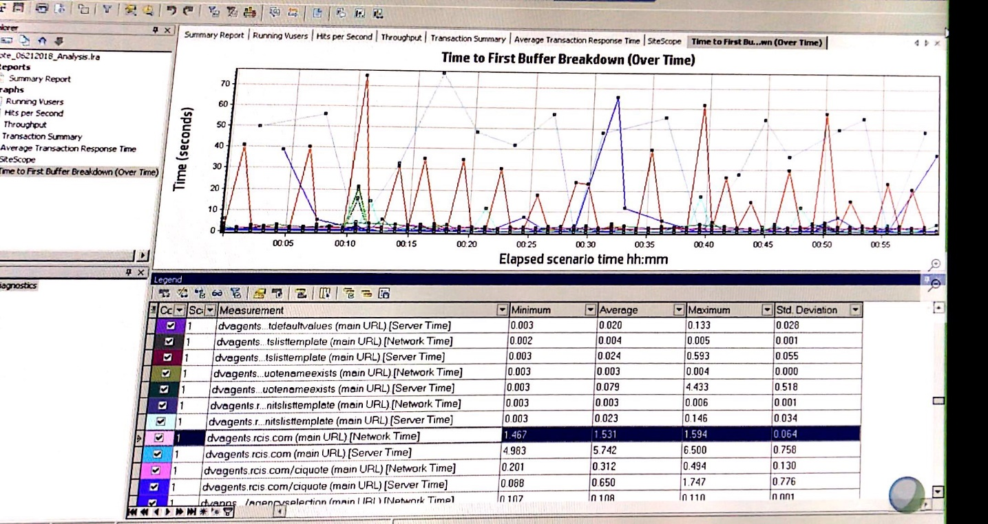

# Day 4 – KT Session on Automation

## Regression Test Life Cycle

Here we have two Execution Life Cycles. We have around 1300 + Scripts.

Cycle1 – Execution Period is 1-2 Weeks

Cycle2 – Execution Period is 3-4 Days

## QC Path for Automation Suite in Test Plan

CIMax🡪 CIMax Classic -- > Automation

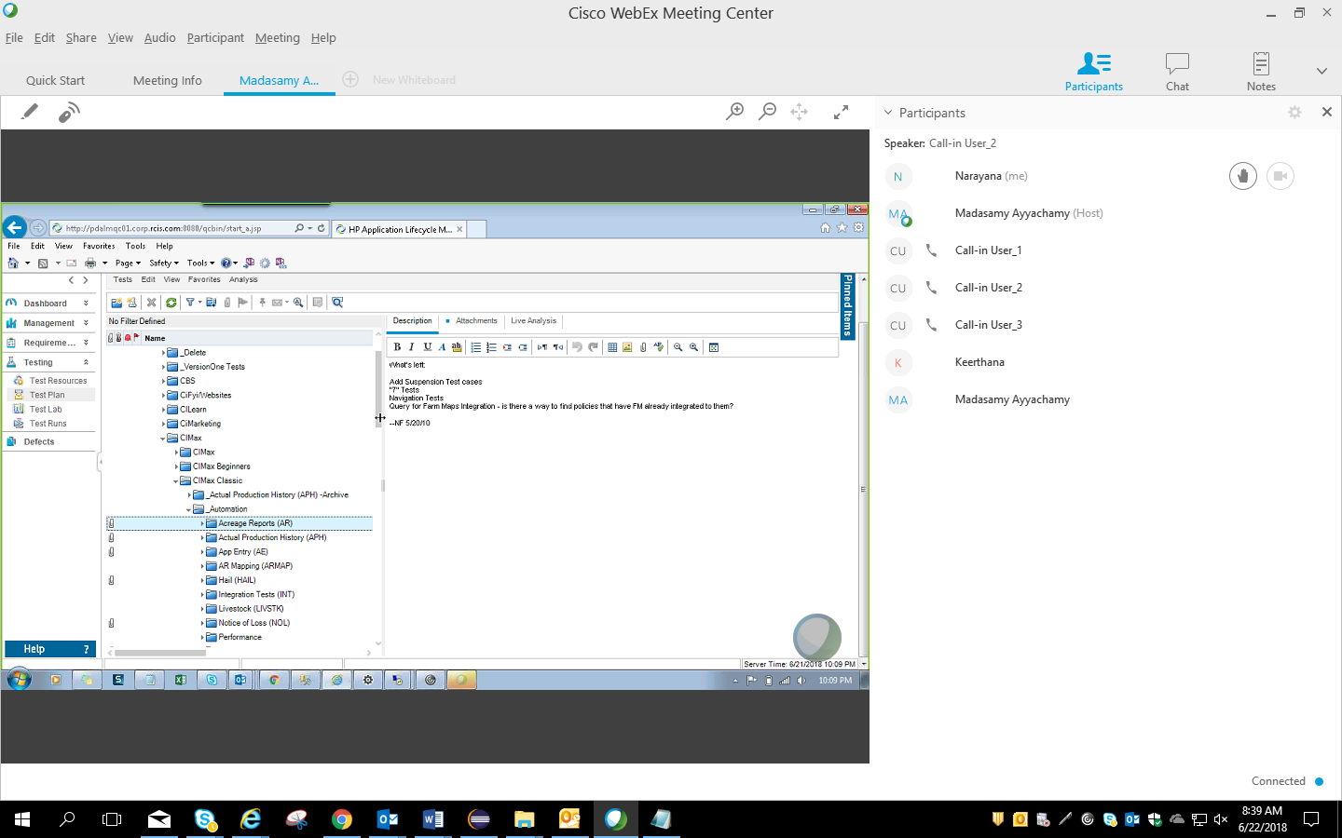

# Glossary

Provided relevant terms and abbreviations used

|  |  |
| --- | --- |
| Acronym | Description |
| RCIS | Rural Community Insurance Services |
| APH | Actual Production History |
| AR | Acreage Report |
| RCIA | Rural Community Insurance Agency |
| RCIC | Rural Community Insurance Co. |
| AIP | Approved Insurance Provider |
| SBI | Substantial Beneficial Interest |
| MPCI | Multiple Peril Crop Insurance |